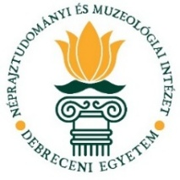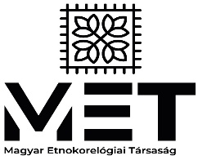 

**APPLICATION FORM**

**V. INTERNATIONAL CONFERENCE OF   
DOCTORAL STUDENTS IN DANCE RESEARCH**

We look forward to receiving your application at [**etnokoreo@gmail.com**](mailto:etnokoreo@gmail.com).

**Application deadline: 25 July 2025**

Name:

Phone number:

Email address:

Name and location of doctoral school:

Name of supervisor:

Title of presentation:

Form of presentation (please choose): on site / online:

Abstract in English (120–150 words):